

**Basic Electronic**

**(*Theory*)**

***Project Report***

***NAME: Muzamil Khan***

***STUDENT ID: 11508***

***CLASS ID: 105015***

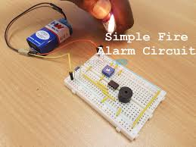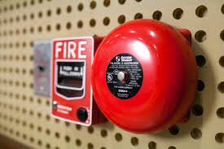

**Project Title: Fire Alarm**



**Project Group Members**

**(11508) Muzamil Khan**

**(11515) Zain Zahid**

**(11508) Osama Rasool**

**Chapter 1:**

**Introduction:**

The project is about working of “Fire-Alarm”.

**Fire Alarm:**

Fire Alarm Circuit is a simple circuit that detects the fire and activates the Siren Sound or Buzzer. Fire Alarm Circuits are very important devices to detect fire in the right time and prevent any damage to people or property.

Fire Alarm Circuits and Smoke Sensors are a part of the security systems which help in detecting or preventing damage. Installing Fire Alarm Systems and Smoke Sensors in commercial buildings like offices, movie theatres, shopping malls and other public places is compulsory.

There are many expensive and sophisticated Fire Alarm Circuit in the form of stand-alone devices, but we have designed five very simple Fire Alarm Circuits using common components like Thermistor, LM358, Germanium Diode, LM341 and NE555.

We will see all these circuit, their circuit diagrams, components required for each circuit and the working of the individual circuit in the following sections.

**About Project:**

Our Project Consist Of Following Circiuts:

1. Resister(r1, r3, r4, r5)
2. Thermister
3. Pototentionermeter
4. 555 ic
5. Capicitor
6. Buzzer

**Resistor:**



Resistor is an electrical component that reduces the electric current.

The resistor's ability to reduce the current is called resistance and is measured in units of ohms (symbol: Ω).

**Thermistor:**

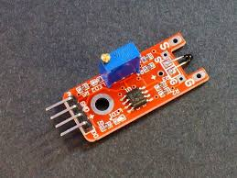

A **thermistor** (or **thermal resistor**) is defined as a [type of resistor](https://www.electrical4u.com/types-of-resistor/) whose [electrical resistance](https://www.electrical4u.com/what-is-electrical-resistance/) varies with changes in temperature. Although all resistors’ resistance will fluctuate slightly with temperature, a thermistor is particularly sensitive to temperature changes.

**555 ic:**

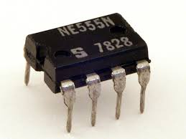

The 555 timer IC is an [integrated circuit](https://en.wikipedia.org/wiki/Integrated_circuit) (chip) used in a variety of [timer](https://en.wikipedia.org/wiki/Timer), delay and in varoius circiuts. Depending on the manufacturer, the standard 555 package includes 25 [transistors](https://en.wikipedia.org/wiki/Transistor), 2 [diodes](https://en.wikipedia.org/wiki/Diode) and 15 [resistors](https://en.wikipedia.org/wiki/Resistor) on a [silicon](https://en.wikipedia.org/wiki/Silicon) chip installed in an 8-pin [dual in-line package](https://en.wikipedia.org/wiki/Dual_in-line_package) (DIP-8). Variants available include the 556 (a DIP-14 combining two complete 555s on one chip),  and 558 / 559 (both a DIP-16 combining four reduced-functionality timers on one chip.

**Capicitor:**

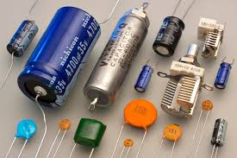

The capacitor is a component which has the ability or “capacity” to store energy in the form of an electrical charge producing a potential difference (*Static Voltage*) across its plates, much like a small rechargeable battery.

There are many different kinds of capacitors available from very small capacitor beads used in resonance circuits to large power factor correction capacitors, but they all do the same thing, they store charge.

**Potentiometer:**

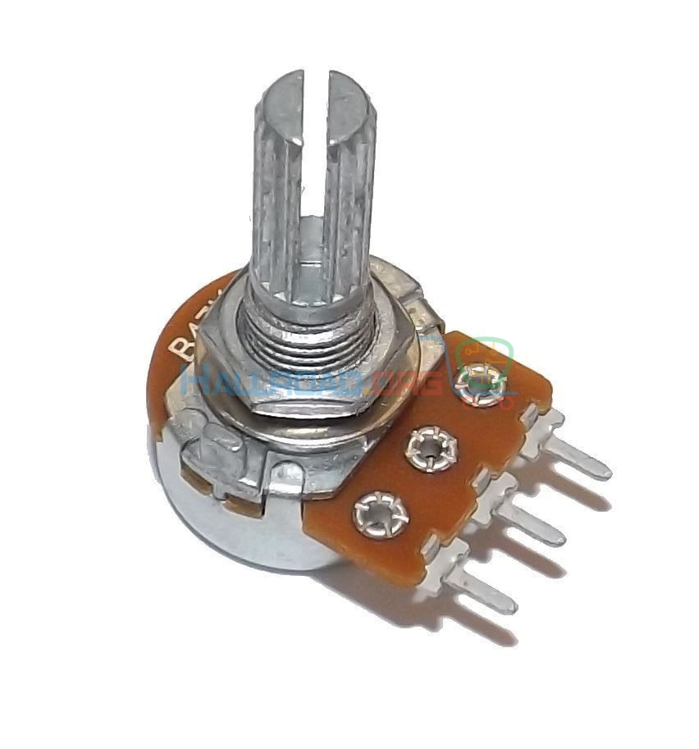

A **potentiometer** (also known as a **pot** or **potmeter**) is defined as a 3 terminal [variable resistor](https://www.electrical4u.com/variable-resistors/) in which the [resistance](https://www.electrical4u.com/what-is-electrical-resistance/) is manually varied to control the flow of [electric current](https://www.electrical4u.com/electric-current-and-theory-of-electricity/). A potentiometer acts as an adjustable [voltage divider](https://www.electrical4u.com/voltage-divider/).

A potentiometer is a [passive electronic component](https://www.electrical4u.com/active-and-passive-elements-of-electrical-circuit/). Potentiometers work by varying the position of a sliding contact across a uniform resistance. In a potentiometer, the entire input [voltage](https://www.electrical4u.com/voltage-or-electric-potential-difference/) is applied across the whole length of the [resistor](https://www.electrical4u.com/what-is-resistor/), and the output voltage is the voltage drop between the fixed and sliding contact as shown below.

**Buzzer:**

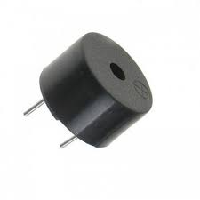

A potentiometer is a [passive electronic component](https://www.electrical4u.com/active-and-passive-elements-of-electrical-circuit/). Potentiometers work by varying the position of a sliding contact across a uniform resistance. In a potentiometer, the entire input [voltage](https://www.electrical4u.com/voltage-or-electric-potential-difference/) is applied across the whole length of the [resistor](https://www.electrical4u.com/what-is-resistor/), and the output voltage is the voltage drop between the fixed and sliding contact as shown below.

**Chapter 2**

**Background:**

***Circiut Diagram Of Fire Alarm: (With Thermistor):***

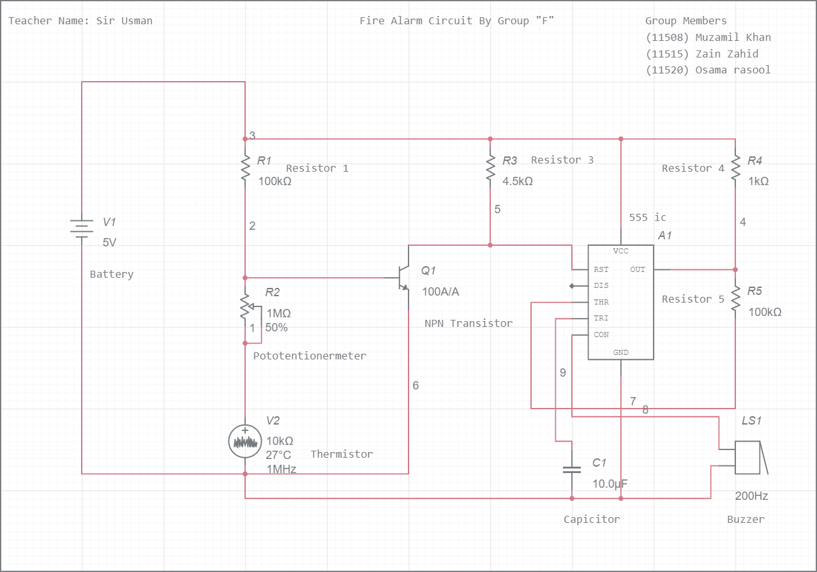

***Circiut Diagram Of Fire Alarm: (Without Thermistor):***

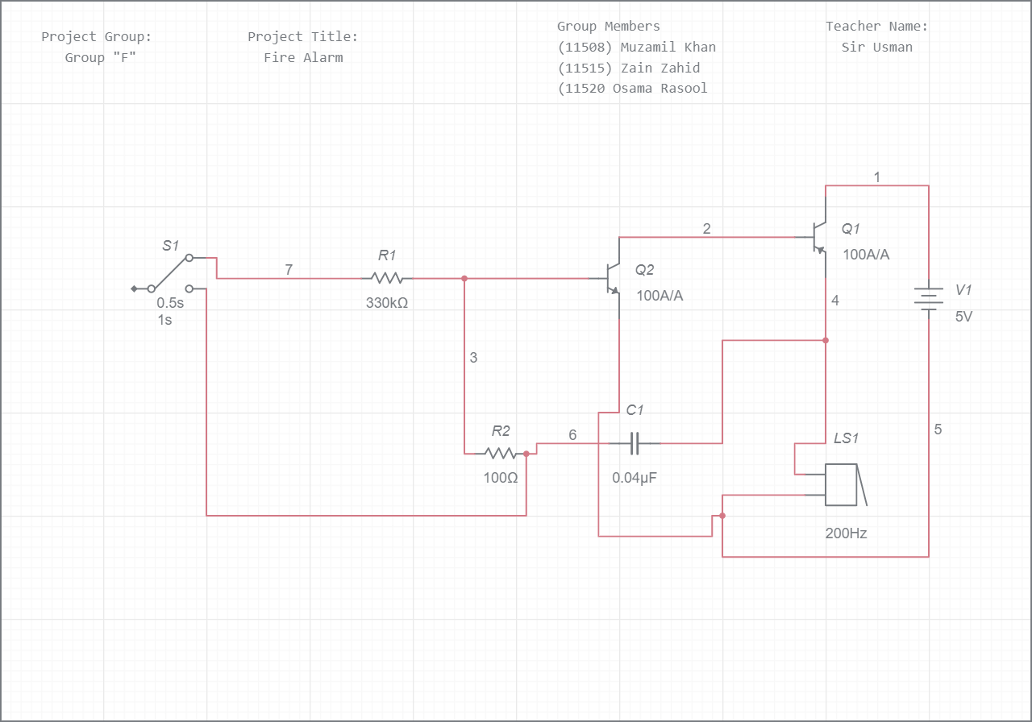

**Discription:**

The design of the Fire Alarm Circuit with Buzzer Sound is very simple. First, connect the 10 KΩ Potentiometer. One end of the POT is connected to R1, other end is connected to Thermistor

We will now Connect npn transistor to our circiut and connected it to 555ic.

We have chosen a small, 5V buzzer in this project to make the alarm or siren sound. So, connect the output of the LM358 Op – amp to the 5V Buzzer directly.

***Chapter 3***

***Methodology:***

Methodology is the part where procedure that have been taken through out the project was summarized.

This fire alarm circuits is built with UM3561 siren IC.A thermistor is used as heat sensor. When the temperature increases, the resistance of the thermistor drops to the tune of 1K at 70 degree Celsius. It consists of three transistors and the preset. This makes a low resistance path for the transistors to conduct the current flow to the speaker .This sets the alarm sound.

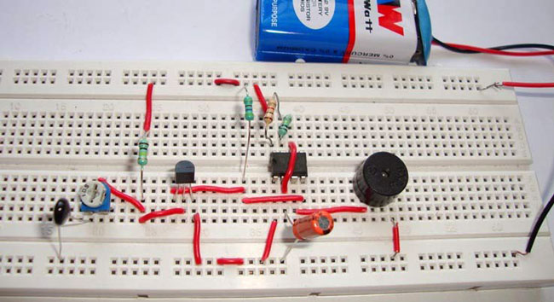

***Chapter 4***

***Working with flow charts***

#### Working of the Simple Fire Alarm Circuit

This circuit uses a thermistor to sense the temperature. When it senses that the temperature of the environment is increasing above a given threshold, then it gives a signal. The temperature at which the circuit detects fire can be adjusted by using the potentiometer arrangement at VR1.

***Get an idea about***[***Thermistor Temperature Sensing Alarm***](https://www.electronicshub.org/thermistor-temperature-sensing-alarm/)***if you are interested.***

When the temperature increases above the set value, the potentiometer arrangement produces a high voltage. This voltage is then given to BC547 transistor in common emitter mode. It is an NPN general purpose transistor. When the base is given a high input, it gets turned on. When the transistor is turned on, its collector voltage is reduced to low as the collector to emitter voltage decreases. The collector output voltage of the first transistor is given to the base as an input to the second BC 547 NPN transistor. This transistor too is in common emitter mode and as the input is low when the temperature threshold is reached, the output at the collector will rise high. In this state, it will turn on the next transistor, i.e. BC107. This transistor will now act as a switch for the siren circuit. This transistor can bear power quite larger than the BC547 and it is also equipped with a heat sink for that purpose.

When the BC107 transistor turns on, it allows current to pass from power supply to ground through collector thereby acting as an electronically controlled switch. When the current is passing, the siren circuit which is assembled as the load to the circuit is turned ON. Then you can hear the siren sound through the buzzer. The capacitors used in the circuit are the main components in producing the siren effect. The principle involved in generating the siren effect is to make an oscillator with an envelope which periodically increases and decreases so as to generate that effect.

**Circiut Working:**



#### Block Diagram of Fire Alarm Circuit Using LM741

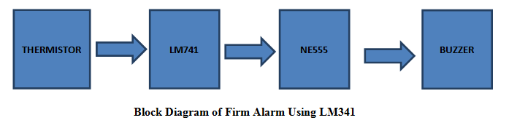

### Circuit 3 Fire Alarm with Siren Sound

This circuit alerts us when there is a fire accident at home by ringing a siren sound. You might have seen fire alarms earlier but this is quite different as it generates a siren sound instead of a buzzer and also it uses basic components to generate that siren sound.

We are aware that there are many integrated circuits which can be used to generate the siren effect but we preferred to use basic electronics components like resistors, capacitors and transistors to generate it so that you will clearly understand the internal working of it and it will be much useful for you as you will gain more knowledge by analyzing it instead of simply going for pre designed integrated circuits.

#### Circuit Diagram

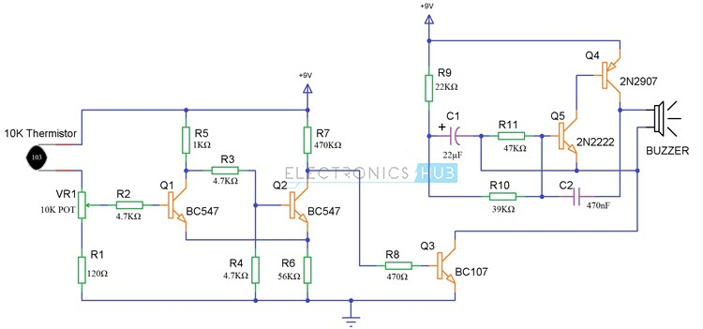

#### Components Required

* 1 x 10K Thermistor
* 2 x BC547 NPN Transistor
* 1 x BC107 NPN Transistor
* 1 x 2N2222 NPN Transistor
* 1 x 2N2907 PNP Transistor
* 3 x 4.7KΩ Resistor (1/4 Watt)
* 1 x 470KΩ Resistor (1/4 Watt)
* 1 x 56KΩ Resistor (1/4 Watt)
* 1 x 47KΩ Resistor (1/4 Watt)
* 1 x 39KΩ Resistor (1/4 Watt)
* 1 x 22KΩ Resistor (1/4 Watt)
* 1 x 1KΩ Resistor (1/4 Watt)
* 1 x 470Ω Resistor (1/4 Watt)
* 1 x 120Ω Resistor (1/4 Watt)
* 1 x 10KΩ Potentiometer
* 1 x 22µF Capacitor (Polarized)
* 1 x 470nF (0.47µF) Ceramic Capacitor
* 1 x Buzzer

#### Working

This circuit uses a thermistor to sense the temperature. When it senses that the temperature of the environment is increasing above a given threshold, then it gives a signal. The temperature at which the circuit detects fire can be adjusted by using the potentiometer arrangement at VR1.

Get an idea about [Thermistor Temperature Sensing Alarm](https://www.electronicshub.org/thermistor-temperature-sensing-alarm/) if you are interested.

When the temperature increases above the set value, the potentiometer arrangement produces a high voltage. This voltage is then given to BC547 transistor in common emitter mode. It is an NPN general purpose transistor. When the base is given a high input, it gets turned on. When the transistor is turned on, its collector voltage is reduced to low as the collector to emitter voltage decreases. The collector output voltage of the first transistor is given to the base as an input to the second BC 547 NPN transistor. This transistor too is in common emitter mode and as the input is low when the temperature threshold is reached, the output at the collector will rise high. In this state, it will turn on the next transistor, i.e. BC107. This transistor will now act as a switch for the siren circuit. This transistor can bear power quite larger than the BC547 and it is also equipped with a heat sink for that purpose.

When the BC107 transistor turns on, it allows current to pass from power supply to ground through collector thereby acting as an electronically controlled switch. When the current is passing, the siren circuit which is assembled as the load to the circuit is turned ON. Then you can hear the siren sound through the buzzer. The capacitors used in the circuit are the main components in producing the siren effect. The principle involved in generating the siren effect is to make an oscillator with an envelope which periodically increases and decreases so as to generate that effect.

Related Post: [***Pull Pin Security Alarm Circuit***](https://www.electronicshub.org/pull-pin-security-alarm-system/)

### Circuit 4 Fire Alarm Circuit Using LM741

Here is another small project on fire alarm. When a fire accident is happened in home or office, it will detect the fire and give the alarm.

#### Block Diagram of Fire Alarm Circuit Using LM741



The thermistor is the main component which detects the fire by sudden change in the room temperature because of the heat generated by the fire. The thermistor will detect the heat and give the information to the LM741 OP-AMP. The op-amp will make the NE555 to generate pulse which has been given to a buzzer to buzz.

**LM741**: LM741 is an operational amplifier which will work according to the difference in the input voltages. LM741 has following features like high current driving, voltage gain, noise amplification and also provide low output impedance. LM741 can also use as a short circuit protection.

#### Circuit Diagram of Fire Alarm Using LM741

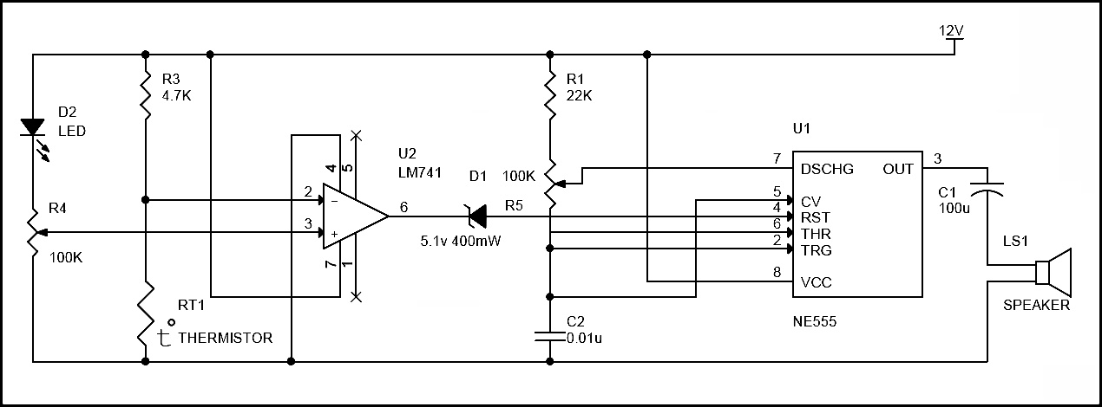

#### Circuit working

* Circuit principle is similar to the first circuit i.e. Thermistor is used to sense the raise in temperature. But it rises only after a fixed temperature.
* Here op amp acts as non-inverting comparator i.e. Vout is positive only if Vin (voltage at pin 2) < VRef (voltage at pin3).
* When there is no any fire, voltage at pin 2 of the comparator is greater than the voltage at pin3.
* When there is no fire resistance of thermistor is 10k. So 10K and 4.7k forms voltage divider circuit.
* Voltage at pin2 is calculate using formula. V= (100*12) / (100+4.7) =11.4
* Voltage at pin 3 =50*12/100=6v (Variable pin of the pot is at 50% of total resistance.)
* When there is any fire thermistor temperature raises and its resistance decreases. So voltage at pin2 starts decreasing. Thus Vout is goes to positive i.e. it is equal to Vcc.
* Here reference voltage selected is 6v.Fire alarm starts only if the input voltage is less than 6v.To increase the reference voltage decrease the resistance of pot.

Also read this interesting post: [***Remote Operated Alarm Circuit***](https://www.electronicshub.org/remote-operated-alarm-circuit/)

### Circuit 5 Fire Alarm Circuit Using Germanium Diode

This is a simple fire alarm circuit using Germanium Diode and 555 timer. In this circuit Germanium Diode play very important role in detecting the fire. This circuit is very easy to construct, cost effective and implementable.

#### Block Diagram of Fire Alarm Circuit Using Germanium Diode



Here is the simple fire alarm circuit which costs less than 100 rupees. The key component in the circuit is DR25 (germanium diode) whose resistance will decrease with increase in temperature. The conduction of germanium diode will start at 70 degrees. So we may use germanium diode as a heat sensor. When the temperature is more than 70 degree, the germanium diode will conduct and trigger the NE555 timer through a transistor. The NE555 is configured in astable Multivibrator and make the buzzer to alarm when germanium diode conducts. So that we can get alert and act according to the alarm.

#### Circuit Diagram of Fire Alarm Using Germanium DiodeFire Alarm Circuit Using Germanium Diode

#### Circuit Working

* The DR25 germanium diode is heat sensor which will conduct when temperature is increased at certain point. The DR25 is made reverse biased in the circuit. It will conduct only when it is more than 70degree of room temperature.
* The DR25 is connected to the transistor in reverse bias, which has high reverse resistance (more than 10K ohm) and  does not make the transistor to turn off which is connected to the reset pin of 555 timer. The reset pin of 555timer will be in ground level when the transistor is turned off. Here, the 555 timer is configured as astable Multivibrator.
* When more than 70degrees in room temperature occurred, the resistance of DR25 diode drops to 1k ohm which will make the transistor to turn off and make the reset pin to go high. This will generate the output at pin3 and make the sound through the alarm.
* We can use 3 or more diodes in reverse bias connected in parallel and placed in different room. If there is fire accident, it will sense and make the alarm.

**Note**

* + If DR25 germanium diode is available, you can still use AC128, AC188 or 2N360 germanium transistors. Use base and emitter junctions in place of cathode and anode.
  + Diode must be connected to the circuit in reverse bias.

***Chapter 5***

***Results***

* Fire Alarm Circuits are very useful in homes, offices, schools, labs, etc. to detect and prevent any disasters due to fire.
* Fire Alarm Systems can work as a stand – alone devices or be a part of a complex home security system with other security features like smoke detection, intruder alert, motion detection, etc.

**ADVANTAGES**

* Quick acting - provides for earlier detection than other types of smoke detectors or thermal detectors.

* It can detect fires that are in the incipient stage or detect other aerosol type smoke products.

* Provide early warning.

* Low cost than thermal detector but it is very useful in emerged stages, not affected by dusty or dirty environments.

* Responds faster than smoke detectors and minimum maintenance only and suitable for protection of property.

***Chapter 6***

***Comparison with other***

### Types of smoke detectors

* **Ionization smoke alarms:** These are best at detecting the small particles released by **fast, flaming fires.** The only downside to ionization smoke alarms is that they’re sensitive. Even the smoke produced by burnt food or by steam from the shower can trigger them, so you may get more false alarms if the alarm is placed in the kitchen or near a bathroom.
* **Photoelectric smoke alarms:** These types of smoke detectors are best at sensing **smoldering fires** that create a lot of smoke without many (or any) visible flames. They’re not as prone to false alarms as ionization smoke detectors, but photoelectric alarms may still be randomly set off if dust builds up inside them.
* **Dual-sensor smoke alarms:** With dual sensor alarms, you get the best of both technologies. But there are still some drawbacks. Some models require both sensors to be triggered before the alarm will go off, but this may delay the alert from sounding. Other models only require one of the sensors to be tripped, but that also creates the potential for more false alarms.
* **Types of smoke detectors**

|  |  |  |
| --- | --- | --- |
| **Type of smoke detector** | **What it’s best at detecting** | **Possible downsides** |
| **Ionization smoke alarm** | Fast, flaming fires with little smoke | Can be triggered by steam or cooking |
| **Photoelectric smoke alarm** | Smoldering, smoky fires | Can be triggered by too much dust |
| **Dual-sensor smoke alarm** | Both types of fire | Delayed alerts or false alarms |

### Things to consider before buying

* There’s more to a smoke alarm than the type of sensor it uses.
* Some devices are battery-powered, while others are hardwired into your home’s electrical system (so you don’t have to deal with that pesky low-battery chirp). You’ll want to examine your electrical wiring to see what will work best for your home.
* Many modern smoke alarms can be wirelessly linked so that when one is triggered, all of them go off. This is called “interconnectability,” and it’s a good idea for big houses where an alarm going off two floors below wouldn’t even wake up the lightest sleeper.
* Other features that you might want in your smoke alarm include digital displays, silence buttons, flashing lights (for the hearing impaired), and smart technology that connects with your phone.
* Many of the devices on this list are equipped with these features, so let’s go ahead and dive into the details.
* **The best smoke detectors of 2020**

|  |  |  |  |  |
| --- | --- | --- | --- | --- |
| **Device** | **Price** | **Sensor type** | **Battery-powered/wired** | **More info** |
| [First Alert BRK 3120B](https://www.amazon.com/First-Alert-Detector-Photoelectric-Hardwired/dp/B00O8MVW44/ref=as_li_ss_tl?ie=UTF8&linkCode=ll1&tag=reviewsorg-20&linkId=d50062e1a5c85b62a790b2f03e0c94fe&language=en_US#_blank) | $49.99 | Dual sensor | Hardwired (with battery backup) | [View on Amazon](https://www.amazon.com/First-Alert-Detector-Photoelectric-Hardwired/dp/B00O8MVW44/ref=as_li_ss_tl?ie=UTF8&linkCode=ll1&tag=reviewsorg-20&linkId=d50062e1a5c85b62a790b2f03e0c94fe&language=en_US#_blank) |
| [Google Nest Protect S3003LWES](https://www.amazon.com/S3000BWES-Protect-Carbon-Monoxide-Battery/dp/B00XV1RD0K/ref=as_li_ss_tl?keywords=nest+protect&qid=1571939292&sr=8-4&linkCode=ll1&tag=reviewsorg-20&linkId=d4ddd85a19fbca450ad81783dddc7425&language=en_US#_blank) | $117.11 | Photoelectric + blue LED + carbon monoxide | Hardwired and battery-powered models available | [View on Amazon](https://www.amazon.com/S3000BWES-Protect-Carbon-Monoxide-Battery/dp/B00XV1RD0K/ref=as_li_ss_tl?keywords=nest+protect&qid=1571939292&sr=8-4&linkCode=ll1&tag=reviewsorg-20&linkId=d4ddd85a19fbca450ad81783dddc7425&language=en_US#_blank) |
| [X-Sense SD03](https://www.amazon.com/X-Sense-Indicator-Auto-Check-Compliant-SD03/dp/B07TGJYHP2/ref=as_li_ss_tl?keywords=10-year+dual+sensor+smoke+alarm&qid=1572472158&s=hi&sr=1-8&linkCode=ll1&tag=reviewsorg-20&linkId=6bc00ae6e7ad64525a69f306adc44e44&language=en_US#_blank) | $27.99 | Photoelectric | 10-year battery | [View on Amazon](https://www.amazon.com/X-Sense-Indicator-Auto-Check-Compliant-SD03/dp/B07TGJYHP2/ref=as_li_ss_tl?keywords=10-year+dual+sensor+smoke+alarm&qid=1572472158&s=hi&sr=1-8&linkCode=ll1&tag=reviewsorg-20&linkId=6bc00ae6e7ad64525a69f306adc44e44&language=en_US#_blank) |
| [First Alert SCO500B](https://www.amazon.com/First-Alert-Wireless-Interconnected-Photoelectric/dp/B0064S9IQ4/ref=as_li_ss_tl?_encoding=UTF8&pd_rd_i=B0064S9IQ4&pd_rd_r=b0ddcc49-79a2-4d5c-aa69-dbfc4ce0397b&pd_rd_w=qsOMp&pd_rd_wg=sWEA0&pf_rd_p=0e5324e1-c848-4872-bbd5-5be6baedf80e&pf_rd_r=63EE93KJHVMA271GRTNB&psc=1&refRID=63EE93KJHVMA271GRTNB&linkCode=ll1&tag=reviewsorg-20&linkId=f51ce40d410feb63cc90bd1d257ee786&language=en_US#_blank) | $59.99 | Photoelectric + carbon monoxide | Hardwired and battery-powered models available | [View on Amazon](https://www.amazon.com/First-Alert-Wireless-Interconnected-Photoelectric/dp/B0064S9IQ4/ref=as_li_ss_tl?_encoding=UTF8&pd_rd_i=B0064S9IQ4&pd_rd_r=b0ddcc49-79a2-4d5c-aa69-dbfc4ce0397b&pd_rd_w=qsOMp&pd_rd_wg=sWEA0&pf_rd_p=0e5324e1-c848-4872-bbd5-5be6baedf80e&pf_rd_r=63EE93KJHVMA271GRTNB&psc=1&refRID=63EE93KJHVMA271GRTNB&linkCode=ll1&tag=reviewsorg-20&linkId=f51ce40d410feb63cc90bd1d257ee786&language=en_US#_blank) |
| [Kidde i12060](https://www.amazon.com/Kidde-i12060-Hardwire-Battery-Backup/dp/B000HEHD8Q/ref=as_li_ss_tl?keywords=cheap+smoke+alarm&qid=1572485501&refinements=p_72:1248909011,p_36:-1500&rnid=1243644011&s=hi&sr=1-3&linkCode=ll1&tag=reviewsorg-20&linkId=106efa3e4cea2a7788e5a86bce4fb3c5&language=en_US#_blank) | $13.99 | Ionization | Hardwired (with battery backup) | [View on Amazon](https://www.amazon.com/Kidde-i12060-Hardwire-Battery-Backup/dp/B000HEHD8Q/ref=as_li_ss_tl?keywords=cheap+smoke+alarm&qid=1572485501&refinements=p_72:1248909011,p_36:-1500&rnid=1243644011&s=hi&sr=1-3&linkCode=ll1&tag=reviewsorg-20&linkId=106efa3e4cea2a7788e5a86bce4fb3c5&language=en_US#_blank) |

***Chapter 7***

***Conclusion***

This small size fire alarm system is used to sense the presence of fire, smoke or any other type of aerosols. It also helps to warn people from danger and we can prevent the accident by its alert sound. We can also use this type of fire alarm system in houses, buildings, industries and other important places to avoid serious fire accidents. After doing this project the new fire alarm and smoke detector sensor can be made using CCTV image with image processing process. Plus, smoke also can be differentiating using image analysis. Normally, for a building which is not occupied with smoke detector, a normal CCTV can be used as a sensor to detect smoke from a fire. Image analysis will be use to detect the smoke so that it can trigger alarm same as function of a smoke sensor. This type of sensor can replace the function of smoke sensor whereby almost all the new building now equipped with CCTV for surveillance purposes.

## Discussion

The common smoke alarm detector was based on light and heat, which is not effective as the house always produce the condition that will trigger alarm such as smoke from cooking. Most of the time the false alarm also will occur as the alarm very sensitive even to dust or insects that approach the alarm. Sometimes the smoke alarm have very long relay before detect the smoke that may cause harm and hazardous. The other type of smoke detector that use battery also will not function if the alarm run of battery, no live safe with the dead battery alarm. Therefore, this new alarm using available CCTV can solve this kind of problem.

## Future Recommendation

Future recommendation is the improvement idea for this kind of project for future research. The recommendation for this project is to built new embedded system inside the CCTV or video camera.

## Cost and commercialize

Cost for this new fire alarm and smoke detector design was actually no extra cost the building already occupied with the CCTV just few installments need to be done to the device to make it function as the desired fire alarm and smoke detector.

**Circuit Diagram:**

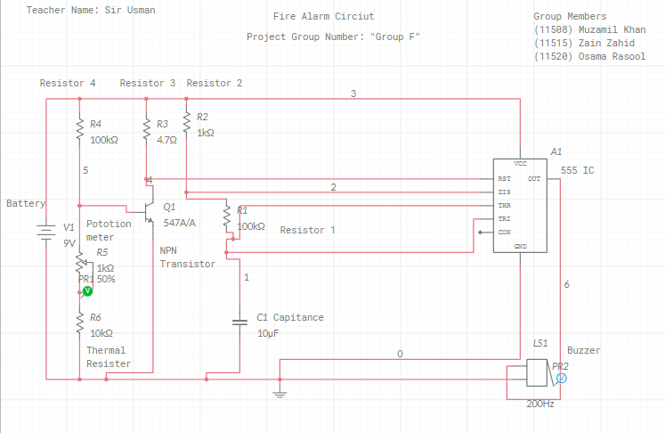

**Multism Circuit Link:**

[**https://www.multisim.com/content/TZ6n2e87wA7Nk6fVwqFpu6/11508-muzamil-khan-fire-alarm-circiut-project/**](https://www.multisim.com/content/TZ6n2e87wA7Nk6fVwqFpu6/11508-muzamil-khan-fire-alarm-circiut-project/)

**……………The End……………**

**Hope You Like Our Report**

**Thanks….**